Retail inflation slight down to 7.04% in May 2022
India’s retail inflation descended to 7.04% on an annual basis in May from 7.79% in April owing to relieving food prices in the month of May.
The overall food inflation rose by 7.97% this month as against 8.31% last month and 5.01% in the corresponding period of last fiscal (FY22).
Consecutively, the headline inflation decelerated to 0.94 per cent in May from 1.43 per cent in April.
The CPI-based inflation has broken the upper limit of RBI’s tolerance band, ranging from 2-6%, for the fifth consecutive month.
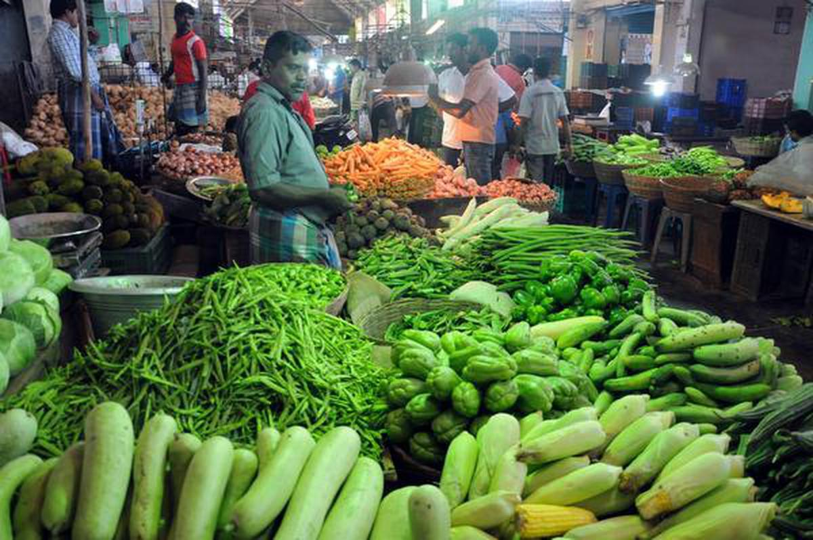
Rising prices in different commodities:
However, with the rising crude oil prices and supply-chain disruptions induced by the Russia-Ukraine war, the effect is expected to be short-lived.
Rising prices of vegetables are creating a cause for concern because they jumped to 18.26 % for May over the same period last year. The sequential rise has been at over 5%.
Fuel and light inflation went up 9.54 per cent in May compared to same period last year. But fuel and light inflation slowed down to 1.4% in May from 3.1% in April.
Estimation:
The data containing all these numbers arrives a few days after the RBI revised India's inflation projection to 6.7% from the earlier approximation of 5.7% in the Monetary Policy Committee’s (MPC) June meeting based on the increase in commodity prices globally.
These factors, along with an average crude oil price (Indian basket) of US$105 per barrel and a normal monsoon in 2022, lead to inflation forecasts of 6.7% in 2022-23, with Q1 at 7.5%; Q2 at 7.4%; Q3 at 6.2%; and Q4 at 5.8%.
The government is waiting for assisting with inflation management in order to keep monetary tightening to a minimum, as a sudden spike in interest rates might help to pace the economic recovery.

Question & Answer:
Q1. What percent of India’s retail inflation has been recorded for May 2022?
Ans. 7.04%
Q2. The overall food inflation increased to what percent?
Ans. 7.97%
Q3. What is the range of RBI’s tolerance band?
Ans. 2% to 6%

